Programming of microprocessor
Module-11
Lecture-5
Computer Programming:

From the discussion of microprocessor 8085 and 8086, it is clear that all the instructions are nothing but the combination of 0s and 1s. ‘0’ indicates a low signal (may be voltage 0V) and ‘1’ indicates a high signal (may be voltage 5V).

On the other hand all the computers work on Von Neuman stored program principle. We have to store the computer program, which is nothing but the set of instruction and computer executes them one other another as per the program requirement.

We have to store the program (i.e. set of instructions) in computer memory. The starting address of the program must be specified which executing the program and it is loaded into the program counter. After that program counter keeps track of the execution of the program till the end of the program.

Every program must be end with a stop or terminating instruction, otherwise the control unit will keep on fetching information from memory. Once it encounters a halt or stop instruction, execution stops.

Simple Example:

Consider that we want to add two numbers 75 and 97.

The first requirement is to keep this two numbers in memory.

Next we have to write a program to fetch this two numbers from memory to CPU and add this two numbers. Finally the result has to be stored in memory.

Again we have to load the program in memory. We must know the memory address of the first instruction where we have stored the program.

While executing the program counter must be loaded with the starting address of the program. The control unit will generate appropriate signal to perform the required task.

Consider that we are using Intel 8085 microprocessor to solve this problem. The task required to perform this operation:
- Get the two numbers from memory to general purpose register.
- Perform the addition operation
- Store the result back into the memory.

Finer details with respect to 8085:

Assume that we store number 75 in memory location 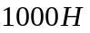. The result will be stored in memory location .

One possible solution:

Step 1: First load the content of memory location to accumulator.

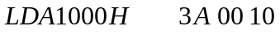 (machine instruction in hexadecimal)

The format of this instruction is opcode Low-order address high order address opcode of LDA is 00 11 10 10 i.e. 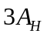

Step 2: Move the contents of accumulator to register B.


The format of this instruction is
0 1 D D D S S S
Destination
register
Source
register

i.e. 0 1 0 0 0 1 1 1 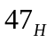(Machine instruction in hexadecimal)

Step 3: Load the content of memory location 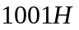to accumulator

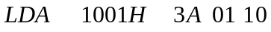(Machine instruction in hexadecimal)

Step : Add the content of register B to accumulator and store the result in accumulator.


The format of this instruction is

1 0 0 0 0 S S S
Source register

i.e. 1 0 0 0 0 0 0 0 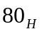(Machine instruction in hexadecimal)

Step 5: Store the result that is present in accumulator to memory location

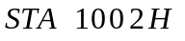 3 2 0 2 1 0 (Machine instruction in hexadecimal)
opcode Lower order address higher order address
opcode of STA is 0 0 1 1 0 0 1 0 i.e. 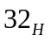

Step 6 : HALT : to indicate the end of program
Opcode of HALT 0 1 1 1 0 1 1 0 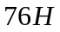

Therefore to carry out this addition, we have to perform these five operation.

In this example we assume that data are available in memory and storing the result in memory.

But if we want to take the input from some input device (like key board), first we have to accept the input from keyboard and stored in some memory location. Similarly to display the result in monitor, we have to get the result from memory and display in monitor with the help of some instruction.

The complete program is :
Memory location
0100H | 3A 00 10 | LDA
0103H | 47 | MOVBA
0104H | 3A 01 10 | LDA 1001H
0107H | 80 | ADD B
0108H | 32 02 10 | STA 1002H
010BH | 76 | HLT

If we store this program from memory location 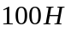, then the contents of memory is shown below:

Memory Address in Hex
in Hex
Fig
While executing the program, the program counter (PC) will be loaded with the starting memory address of this program, i.e. 0100H.

The processor will start execution this program starting from memory location 0100H and it keeps on doing the execution job till it encounters a halt instruction.

If we program the microprocessor in this way, i.e writing the machine code directly, it is known as machine language programming.

The main advantage of machine language programming is that the memory control is directly in the hands of the programmer, so that, he/she may able to manage the memory of the system more efficiently.

The disadvantages of machine language programming are more prominent.

The programming, coding and resource management techniques are tedious. The programmer has to take care of al these functions.

The programs are difficult to understand unless one has a thorough technical knowledge of the processor architecture and the instruction set.

Also it is difficult to remember the machine code of each and every instruction,.

Assembly Language programming:

The assembly language programming is simpler as compared to the machine language programming.

The instruction mnemonics are directly used in the assembly language programming. There is an one-to –one correspondence between instruction mnemonics and machine instruction.

An assembler is used to translate the assembly language programming to machine code.

The program written in assembly language programming is more readable than machine language programming.

The main improvement in assembly language over machine language is that the address value and the contents can be identified by labels.

The assembly language instruction sequence for 8085 microprocessor of the previously discussed program will look like:

 // Load accumulator from memory address
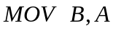 // Move the content from accumulator to B
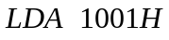 // Load accumulator from memory address 1001H
 // Add the content of B to accumulator and store the result in accumulator
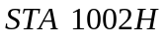 // Store the content of accumulator in memory location 1002H
 // Halt

Another assembly language instruction sequence to solve the same problem.

 // Load lower order byte of address 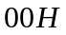to register
// Load higher order byte of address 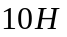to register 
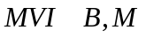// Move the contents of memory location addressed by pair to 
// Load the accumulator from memory location
 // Add the content of to accumulator
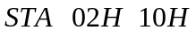// Store the content of accumulator to memory location
// Halt.

The H-L register pair is loaded with 1000H which is the address of first input. This is done in first two instruction.

Moving the contents of memory location 1000H to the register B. It is done in third instruction.
Next we are loading the accumulator from the memory location 1001H, which is the second input. This is done in fourth instruction.

Te content of register B is added with the content of accumulator and store the result in accumulator. It is done in fifth instruction.

The content of accumulator is stored in memory location 1002H. It is done in sixth instruction.

Seventh instruction is to halt the processor, i.e, to stop the program execution.

The first two instructions can be replaced

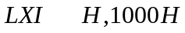

Assembly language instruction sequence for the same program for 8086 microprocessor.

Consider that data segment starts from and code segment starts from 1000H.

 // Initialize DS at 2000H
 //
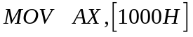 // Get first operand in AX
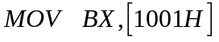 // Get second operand in BX
 // Perform addition
 // Store the result in location 1002H
// Stop

Since the immediate data cannot be loaded into a segment register, the data is transferred to one of the general purpose register, i.e. CX, and then the register content is moved to the segment register DS.

The data segment register contains 2000H.

The effective address of the operands are 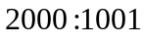 i.e. 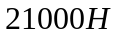 and 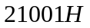

The result is stored in memory location 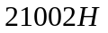.

Problem: Find out the largest number from an unordered array of sixteen 8 bit numbers stored sequentially in the memory locations starting at 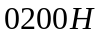.

Assembly language instruction sequence for 8085 microprocessor.

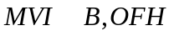 // put OFH in register B to count the number of input elements

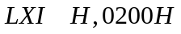 // Load the register pair H-L by which is address of the first element.

 // The content of memory location pointed by H-L register pair is moved to accumulator.

BACK: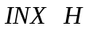// Increment the register pair H-L to get the next element

The content of the memory location whose address is in H-L pair is subtracted from the accumulator. The accumulator remain unchanged. 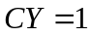 if 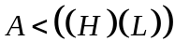

 // Jump to the level ‘NEXT’ if the carry is not set, i.e, content of accumulator is biggest so far.

 // if carry is set, the content of the memory addressed by 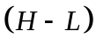pair is biggest so far, so putting it in accumulator.

NEXT: // Decrement the content B, to indicate we have checked one more element

 // jump on not zero, content of B indicates numbers of elements to read, and repeat the process.

// Finalize the input and store.
Assembly language instruction sequence for 8086 microprocessor

Here assume that the data segment stands from memory location 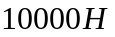

 // initialize counter for number of iteration

 // initialize data segment

//

 // initialize source pointer

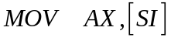 // take first number in AX

BACK:  // increment source pointer.

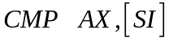 // compare next number with the previous
 // If the next number is smaller, jump to NEXT.

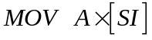 // If the next number is bigger, replace the previous one with the next element

NEXT: LOOP BACK // Repeat the procedure for 15 times.
HLT

CMP operation subtract the source operand from the destination operand, but does not store the result any where. The carry flag is set if the source operand is greater than the destination operand.

LOOP: This instruction executes the part of the program from the label in the instruction to the loop instruction, CX number of times. At each iteration CX is decremented automatically. This instruction basically implements decrement counter and jump if not zero structure.

Example: Write a program to move a string of data bytes from offset to . The length of the string is .

Assembly language instruction sequence for 8085 microprocessor:

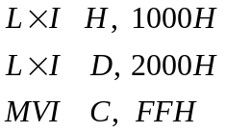

LOOP: 
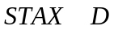 // The content of register A is moved to the memory location whose address is in register pair D-E







 // Jump on not zero, i.e. the result of decrement is not zero.

Assembly language instruction sequence for 8086 microprocessor.

In 8086, we have to define the data segment by setting the DS register. Assume that DS is set appropriately

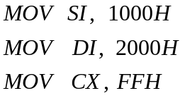

LOOP: 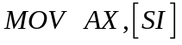






HLT

The program listing is similar to the program of 8085, every instruction of 8085 is replaced by an equivalent instruction of 8086.

Therefore, the above program listing is correct. But this is not an efficient implementation for 8086, because we have not used any advance feature of 8086.

Alternate program listing for 8086 microprocessor

Assume that the data segment register and extra segment registers are set appropriately.




CLD instruction clears the direction flag.

If the direction flag bit is ‘0’, the string is processed in auto increment mode.

REP : This instruction is used as a prefix to other instructions. The instruction to which the REP prefix is provided, is executed repeatedly until the CX register becomes zero. At each iteration CX is decremented by one automatically. When CX becomes zero, the execution proceeds to the next instruction in sequence.

MOVSB : A string of bytes stored in a set of consecutive memory locations is moved to another set of destination locations.

